Title Page:
Comparison Analysis of Development Time on Medication Reminder App for a Comparative Study between Android Application and iOS Application

Nisha. N1, Dr T Suresh Balakrishnan2
Nisha N¹
Research Scholar,
Department of Computer Science Engineering,
Saveetha School of Engineering,
Saveetha Institute of Medical and Technical Sciences,
Saveetha University, Chennai, Tamil Nadu, India. Pin code: 602105
192011495L.sse@saveetha.com

Dr T Suresh Balakrishnan²
Project Guide, Corresponding Author
Department of Computer Science Engineering,
Saveetha School of Engineering,
Saveetha Institute of Medical and Technical Sciences,
Saveetha University, Chennai, Tamil Nadu, India. Pin code: 602105
sureshbalakrishnant.sse@saveetha.com

Keywords: iOS Application, Android Application, Development Time, Medication-Reminder, Treatment, Research
ABSTRACT:

Aim: The goal of this project is to analyze the development time and user navigation durations observed during the treatment process on both the Medication-Reminder Android application and the iOS platform. Materials and Methods: To improve the assessment of development time in treatment procedures, a sample of 10 participants will utilize both an Android application and an iOS application for text summarization. Gpower analysis will be employed with 80% power to determine the appropriate sample size. Result: The assessment of treatment on the Android application indicates a development time of 34.42 hours, while the iOS application surpasses it with a development time of 28.75 hours. Statistical analysis highlights a significant difference between the Android and iOS platforms, supported by a p-value of 0.001 (p < 0.05). Conclusion: With a development time of 28.75 hours, the iOS application outperforms the Android application, which demonstrates a development time of 34.42 hours. This underscores a performance disparity between the two platforms.

Keywords: iOS Application, Android Application, Development Time, Medication-Reminder, Treatment, Research

INTRODUCTION:

This study conducts a quantitative analysis of navigation duration between the Medication-Reminder iOS and Android applications during the treatment process (Tabi et al. 2019)(Tabi et al. 2019). Utilizing rigorous metrics, the research identifies differences in user experiences and system performance across the two platforms, offering developers opportunities to iteratively improve interfaces and enhance user satisfaction (Ahmed et al. 2018)(Ahmed et al. 2018). These insights empower organizations to make informed decisions regarding treatment-related activities, fostering maximum participation through medication reminder utilization (Salgado et al. 2018)(Salgado et al. 2018). Ultimately, our study contributes valuable insights to the broader discourse on digital user experience, facilitating the enhancement of online application design to promote seamless interaction with medical platforms (Santo et al. 2016)(Santo et al. 2016). Ultimately, our findings will inform developers and stakeholders about opportunities for enhancement and optimization to elevate user experience and satisfaction (Grindrod, Li, and Gates 2014)(Grindrod, Li, and Gates 2014).

In the vast landscape of medication reminder research, a plethora of scholarly literature is available through reputable platforms. The IEEE Xplore digital repository hosts (1,258 journals), while ScienceDirect offers access to a substantial collection of (1,78,590 articles). The Google Scholar database boasts an extensive repository comprising (3,270,000 articles), and Springer Publishers contribute (8,290 articles) to the available literature. This paper embarks on a comprehensive exploration of performance metrics related to development time in the Medication-Reminder application (J. Y. E. Park et al. 2019)(J. Y. E. Park et al. 2019). Through meticulous examination of time durations for various actions and processes within the app, including loading screens, feature accessibility, and command execution, we aim to provide a thorough overview of its responsiveness (George, Hassali, and Amar-Singh 2018)(George, Hassali, and Amar-Singh 2018). Furthermore, our objective is to identify potential bottlenecks or inefficiencies that could hinder user experience and productivity. By conducting a detailed performance analysis, we seek to offer actionable recommendations for optimizing the Medication-Reminder application to ensure seamless functionality and enhance user satisfaction (Loy, Ali, and Yap 2016)(Loy, Ali, and Yap 2016).
Moreover, this study contributes valuable insights to the broader discourse on mobile application performance evaluation, with implications for improving the usability and effectiveness of orthopedic assistance tools like Medication-Reminder (Wiecek et al. 2020)(Wiecek et al. 2020). Recognizing the significance of prompt responses in orthopedic support applications, we embark on a systematic inquiry to evaluate the effectiveness of the Medication-Reminder platform. Ultimately, our findings will inform developers and stakeholders about opportunities for enhancement and optimization to elevate user experience and satisfaction (Jácome et al. 2021)(Jácome et al. 2021). By deepening our understanding of development time dynamics, this research contributes to the advancement of mobile health technology and orthopedic care.
Evaluating the effectiveness of online applications is crucial in technology-driven philanthropy, ensuring smooth and user-friendly contribution processes. This investigation centers on comparing development time during navigation between the Medication-Reminder iOS platform and its Android counterpart throughout the contribution process (Chiang et al. 2018)(Chiang et al. 2018). By exploring the nuanced aspects of digital philanthropy, this study aims to shed light on user engagement dynamics specific to treatment transactions, addressing a notable gap in the current literature . With a multidisciplinary research team comprising experts in usability, philanthropy, and human-computer interaction, the study is well-positioned to provide comprehensive insights. The ultimate goal is to improve user experiences in the digital treatment context by offering empirical data on the performance of the Medication-Reminder Android application and iOS platform during treatment procedures (D. Y. Park et al. 2017)(D. Y. Park et al. 2017).

Materials & Methods:

The study is done at the Ideation Laboratory within the Computer Science and Engineering department of the Saveetha School of Engineering, affiliated with the broader Saveetha Institute of Medical and Technical Sciences. This study employs a structured approach involving two distinct groups: Group 1 focuses on exploring the intricacies of the Android application, while Group 2 delves into the realm of the iOS application (Kim et al. 2018)(Kim et al. 2018). Utilizing a robust methodology, the research sets the G-power at a strong 80% and employs the Clincalc Website's analytical power to estimate the optimal iteration sample size. Through meticulous calculation, the study determines an appropriate number of iterations, set at 10 for each group, resulting in a total sample size of 20 (Shtrichman et al. 2018)(Shtrichman et al. 2018).

XAMPP is a software program designed to streamline establishing a local web server environment on a PC, making it efficient and straightforward. It simplifies the creation and configuration of essential Android development components, allowing users to install and operate a fully functional web server on their computers. The acronym "XAMPP" denotes its key components: Apache, MariaDB (formerly MySQL), PHP, and Perl. XAMPP primarily facilitates the development and testing of websites and Android applications in a controlled local environment before deployment to a live server. This eliminates the need for users to install and manage individual components such as web servers, database servers, and programming languages. By enabling developers to swiftly set up a local server environment that closely resembles a production server's setup, XAMPP facilitates testing the functionality and interoperability of Android applications without requiring an internet connection. Particularly advantageous for developers working with PHP and MySQL, as these components are included in the XAMPP package, it is a reliable and user-friendly solution for simplifying the setup of a local web server. This streamlined process aids developers in focusing more time on building and refining their Android projects in a secure environment on their personal computers. Overall, XAMPP is a valuable tool for Android developers due to its quick and easy setup process for local server development and testing. Its intuitive interface and comprehensive features make it a preferred choice for developers worldwide.

The architecture of the iOS application integrates a specialized API designed to enable smooth connectivity with the XAMPP server. Leveraging the Swift programming language, the application efficiently coordinates and interacts with this API. Typically, HTTP GET requests are utilized to communicate with specific API endpoints, triggering corresponding PHP scripts on the server. These PHP scripts act as API handlers, retrieving pertinent data from the database and formatting it into the widely used JSON format before transmitting it back to the iOS application. This systematic approach enhances the efficiency and efficacy of data transfer between the application and the server. Similarly, within the Android application, embedded PHP code governs the connection to the XAMPP server. PHP scripts are pivotal in establishing communication with the server's MySQL database, facilitating simplified access and manipulation of stored data. This intricate process ensures seamless interaction between the Android application and the MySQL database hosted on the XAMPP server. PHP scripts function as adaptable intermediaries, enabling dynamic engagement with the database through SQL queries to meet the evolving data requirements of the Android application.

iOS application

The objective of this project is to enhance the system to offer users a smoother and more responsive experience. Group 1's preparations utilize the iOS application as a reference point, concentrating on minimizing navigation delays and development time during treatment and medical request procedures within the Medication-Reminder iOS application. The aim is to reduce delays and ensure timely communication through strategic improvements and refined procedures, thereby enhancing the overall efficiency of the application for treatment within the dynamic medication reminder environment. Further insights are provided in Table 1, which presents the pseudocode of the iOS Application and encapsulates the central processing unit.

Android application

In our efforts to enhance the user experience and responsiveness of our system, our primary focus is on improving the system architecture. Group 2 will utilize the Android application as a preparatory example, with a focus on addressing issues related to development time and navigation latency during treatment procedures within the Medication-Reminder Android application. This involves optimizing data, implementing server-side modifications, and deploying efficient algorithms. Through careful adjustment of these parameters, our objective is to minimize latency and enhance real-time updates, thus enabling smooth and enjoyable user interaction with the application. Additionally, by integrating user feedback and conducting iterative testing, key elements of the continuous development process, we can tailor the performance of the Android application to meet the evolving needs of medication reminder users. Table 2 presents the pseudocode for the Android Application.

Statistical Analysis

IBM SPSS is widely acknowledged as a valuable research tool for organizing statistical data across various industrial sectors. It offers a range of commonly used computations, including mean, F-value, degrees of freedom (df), and standard error, which are crucial for evaluating significance (Roosan et al. 2020)(Roosan et al. 2020). The primary objectives of using SPSS include computing development time and extracting resource allocation data from the dataset, which are vital for understanding and addressing delays in the Medication-Reminder application's development time during real-time navigation in treatment procedures.

RESULTS

Table. 1 The outlined procedure presents a structured approach to monitor development time within the Xcode "Medication-Reminder" application. By adhering to these steps, users can effectively observe and analyze network activity to gain insights into development time patterns.

Table. 2 The provided guidelines offer a systematic method for tracking development time within an Android application using browser developer tools, providing step-by-step instructions.

Table. 3 shows that text data has been submitted with a sample size of N = 10. development time rates for developing iOS and Android apps are calculated every ten iterations. In terms of accuracy, the iOS application exhibits better performance than the Android application.

Table. 4 This entails comparing data from various samples using the Android Development Algorithm and iOS. Android development requires 34.42 hours of data on average, compared to iOS development's 28.75 hours. The corresponding relative standard deviations for iOS and Android development are 2.301 and 4.166, respectively. For iOS and Android Development, respectively, the standard error mean is 0.664 and 1.203.

Table. 5 A T-Test is used to compare iOS and the Android Development Algorithm using a 95% confidence interval in statistically independent samples. The findings indicate a statistically significant difference between the Android Development and iOS algorithms, with a p-value of 0.001 (p<0.05).

Fig. 1 displays the patient dashboard screen of the Medication-Reminder application from the patient login where the patient can view his daily tasks and complete them every day. By choosing the date on the calendar the patient can view the tasks assigned to him on that particular day and verify.

Fig. 2 The comparison reveals that the mean development time for the iOS algorithm is 28.75, while for the Android Development method, it is 34.42. The Y-axis represents the mean development time, while the X-axis illustrates the comparison between iOS and Android Development approaches, with error bars extending to ±2 standard deviations.

Fig. 3 The figure displays the patient task table from the database of the Medication-Reminder application. This table contains the serial no, patient ID, selected titles for patients, data, and feedback. This table helps the doctor and patient to interact with each other regarding the problems that the patient is going through and the feedback that the doctor gives to the patient to maintain good health.

DISCUSSION

The significance value is determined from the results of an independent sample T-test analysis. In summary, the iOS application exhibits faster performance, with a development time of 28.75 hours compared to the Android application, which operates with a slower consumption of 34.42 hours. The calculated significance level is 0.001, indicating a value smaller than 0.05.

This study delves into the essential doctor-patient relationship, exploring development time in treatment procedures through iOS and Android applications. It highlights the significance of timely responses and examines how real-time monitoring provided by Android and iOS platforms enhances the user experience (Roosan et al. 2020)(Roosan et al. 2020). Moreover, the study emphasizes the importance of technological solutions such as efficient algorithms and data optimization in addressing navigation delays and improving system architecture (Escobar-Viera et al. 2020)(Escobar-Viera et al. 2020). Additionally, it elucidates the iterative processes of continuous testing and user feedback within the Medication-Reminder framework (Bartlett Ellis et al. 2019)(Bartlett Ellis et al. 2019). Discussions primarily focus on enhancing development time, improving user interfaces, and strategically leveraging technology to enhance the effectiveness of Medication-Reminder's treatment procedures (Mendiola, Kalnicki, and Lindenauer 2015)(Mendiola, Kalnicki, and Lindenauer 2015). The research underscores the iterative nature of the Medication-Reminder platform's user feedback process, emphasizing ongoing testing and enhancement to better align with user experiences and preferences (Sharma et al. 2022)(Sharma et al. 2022). This iterative approach not only demonstrates the platform's adaptability to user demands but also serves as a deliberate strategy to maximize Medication-Reminder's overall effectiveness (Thomson et al. 2018)(Thomson et al. 2018).

The project's success relies on several critical components working together to achieve its objectives. Adequate financial, human, and technological resources are essential for progress. Clearly defined targets and timelines, coupled with effective planning and execution, are necessary to steer the project toward its desired outcomes. Active involvement and fostering open communication are crucial for establishing a shared understanding and commitment to project objectives. Effective risk management strategies, including identifying and addressing obstacles, are vital for success. Selecting and employing appropriate technology and tools are crucial for ensuring project efficiency. Projects with legal implications must adhere to all relevant laws and regulations. The competence and collaborative efforts of the project team also play a significant role in overall success.

CONCLUSION

Our analysis of the Medication-Reminder iOS and Android applications, with a special emphasis on treatment protocols, found that the Android application used more development time than the iOS. Based on a resource allocation dataset, we conducted an analysis and found that there was a notable variation in the two platforms' development time. It is noteworthy that the iOS app performed exceptionally well in calculating network demand it only used 28.75 hours of development time, whereas the Android app used 34.42 hours. Surprisingly, our study indicates that the iOS app presents findings more effectively than the Android version. The comparison's statistical significance (p<0.05) is indicated by the computed p-value of 0.001.

REFERENCES

Ahmed, Imran, Niall Safir Ahmad, Shahnaz Ali, Shair Ali, Anju George, Hiba Saleem Danish, Encarl Uppal, et al. 2018. “Medication Adherence Apps: Review and Content Analysis.” JMIR mHealth and uHealth 6 (3): e6432.
Bartlett Ellis, Rebecca J., James H. Hill, K. Denise Kerley, Arjun Sinha, Aaron Ganci, and Cynthia L. Russell. 2019. “The Feasibility of a Using a Smart Button Mobile Health System to Self-Track Medication Adherence and Deliver Tailored Short Message Service Text Message Feedback.” JMIR Formative Research 3 (2): e13558.
Chiang, Nicole, Michael Guo, K. Rivet Amico, Lou Atkins, and Richard T. Lester. 2018. “Interactive Two-Way mHealth Interventions for Improving Medication Adherence: An Evaluation Using The Behaviour Change Wheel Framework.” JMIR mHealth and uHealth 6 (4): e9187.
Escobar-Viera, César, Zhi Zhou, Jamie P. Morano, Robert Lucero, Spencer Lieb, Sean McIntosh, Kevin A. Clauson, and Robert L. Cook. 2020. “The Florida Mobile Health Adherence Project for People Living With HIV (FL-mAPP): Longitudinal Assessment of Feasibility, Acceptability, and Clinical Outcomes.” JMIR mHealth and uHealth 8 (1): e14557.
George, Doris, Mohamed Azmi Hassali, and H. S. S. Amar-Singh. 2018. “Usability Testing of a Mobile App to Report Medication Errors Anonymously: Mixed-Methods Approach.” JMIR Human Factors 5 (4): e12232.
Grindrod, Kelly Anne, Melissa Li, and Allison Gates. 2014. “Evaluating User Perceptions of Mobile Medication Management Applications With Older Adults: A Usability Study.” JMIR mHealth and uHealth 2 (1): e3048.
Jácome, Cristina, Rute Almeida, Ana Margarida Pereira, Rita Amaral, Sandra Mendes, Magna Alves-Correia, Carmen Vidal, et al. 2021. “Feasibility and Acceptability of an Asthma App to Monitor Medication Adherence: Mixed Methods Study.” JMIR mHealth and uHealth 9 (5): e26442.
Kim, Ben Y. B., Anis Sharafoddini, Nam Tran, Emily Y. Wen, and Joon Lee. 2018. “Consumer Mobile Apps for Potential Drug-Drug Interaction Check: Systematic Review and Content Analysis Using the Mobile App Rating Scale (MARS).” JMIR mHealth and uHealth 6 (3): e8613.
Loy, John Shiguang, Eskinder Eshetu Ali, and Kevin Yi-Lwern Yap. 2016. “Quality Assessment of Medical Apps That Target Medication-Related Problems.” Journal of Managed Care & Specialty Pharmacy, September. https://doi.org/10.18553/jmcp.2016.22.10.1124.
Mendiola, Martin F., Miriam Kalnicki, and Sarah Lindenauer. 2015. “Valuable Features in Mobile Health Apps for Patients and Consumers: Content Analysis of Apps and User Ratings.” JMIR mHealth and uHealth 3 (2): e4283.
Park, Daniel Y., Elizabeth M. Goering, Katharine J. Head, and Rebecca J. Bartlett Ellis. 2017. “Implications for Training on Smartphone Medication Reminder App Use by Adults With Chronic Conditions: Pilot Study Applying the Technology Acceptance Model.” JMIR Formative Research 1 (1): e8027.
Park, Jamie Yea Eun, Jenny Li, Alyssa Howren, Nicole Wen Tsao, and Mary De Vera. 2019. “Mobile Phone Apps Targeting Medication Adherence: Quality Assessment and Content Analysis of User Reviews.” JMIR mHealth and uHealth 7 (1): e11919.
Roosan, Don, Jay Chok, Mazharul Karim, Anandi V. Law, Andrius Baskys, Angela Hwang, and Moom R. Roosan. 2020. “Artificial Intelligence–Powered Smartphone App to Facilitate Medication Adherence: Protocol for a Human Factors Design Study.” JMIR Research Protocols 9 (11): e21659.
Salgado, Teresa M., Alexa Fedrigon, Donna Riccio Omichinski, Michelle A. Meade, and Karen B. Farris. 2018. “Identifying Medication Management Smartphone App Features Suitable for Young Adults With Developmental Disabilities: Delphi Consensus Study.” JMIR mHealth and uHealth 6 (5): e9527.
Santo, Karla, Sarah S. Richtering, John Chalmers, Aravinda Thiagalingam, Clara K. Chow, and Julie Redfern. 2016. “Mobile Phone Apps to Improve Medication Adherence: A Systematic Stepwise Process to Identify High-Quality Apps.” JMIR mHealth and uHealth 4 (4): e6742.
Sharma, Shreya, Katherine Gergen Barnett, John (jack) Maypole, and Rebecca Grochow Mishuris. 2022. “Evaluation of mHealth Apps for Diverse, Low-Income Patient Populations: Framework Development and Application Study.” JMIR Formative Research 6 (2): e29922.
Shtrichman, Ronit, Stefan Conrad, Kai Schimo, Ran Shachar, Ehud Machluf, Enrique Mindal, Howard Epstein, Shirli Epstein, and Alan Paz. 2018. “Use of a Digital Medication Management System for Effective Assessment and Enhancement of Patient Adherence to Therapy (ReX): Feasibility Study.” JMIR Human Factors 5 (4): e10128.
Tabi, Katarina, Abnashi Singh Randhawa, Fiona Choi, Zamina Mithani, Friederike Albers, Maren Schnieder, Mohammadali Nikoo, et al. 2019. “Mobile Apps for Medication Management: Review and Analysis.” JMIR mHealth and uHealth 7 (9): e13608.
Thomson, Karen, Corline Brouwers, Olga C. Damman, Martine C. de Bruijne, Danielle R. M. Timmermans, and Marijke Melles. 2018. “How Health Care Professionals Evaluate a Digital Intervention to Improve Medication Adherence: Qualitative Exploratory Study.” JMIR Human Factors 5 (1): e8948.
Wiecek, Elyssa, Andrea Torres-Robles, Rachelle Louise Cutler, Shalom Isaac Benrimoj, and Victoria Garcia-Cardenas. 2020. “Impact of a Multicomponent Digital Therapeutic Mobile App on Medication Adherence in Patients with Chronic Conditions: Retrospective Analysis.” Journal of Medical Internet Research 22 (8): e17834.
Ahmed, Imran, Niall Safir Ahmad, Shahnaz Ali, Shair Ali, Anju George, Hiba Saleem Danish, Encarl Uppal, et al. 2018. “Medication Adherence Apps: Review and Content Analysis.” JMIR mHealth and uHealth 6 (3): e6432.
Bartlett Ellis, Rebecca J., James H. Hill, K. Denise Kerley, Arjun Sinha, Aaron Ganci, and Cynthia L. Russell. 2019. “The Feasibility of a Using a Smart Button Mobile Health System to Self-Track Medication Adherence and Deliver Tailored Short Message Service Text Message Feedback.” JMIR Formative Research 3 (2): e13558.
Chiang, Nicole, Michael Guo, K. Rivet Amico, Lou Atkins, and Richard T. Lester. 2018. “Interactive Two-Way mHealth Interventions for Improving Medication Adherence: An Evaluation Using The Behaviour Change Wheel Framework.” JMIR mHealth and uHealth 6 (4): e9187.
Escobar-Viera, César, Zhi Zhou, Jamie P. Morano, Robert Lucero, Spencer Lieb, Sean McIntosh, Kevin A. Clauson, and Robert L. Cook. 2020. “The Florida Mobile Health Adherence Project for People Living With HIV (FL-mAPP): Longitudinal Assessment of Feasibility, Acceptability, and Clinical Outcomes.” JMIR mHealth and uHealth 8 (1): e14557.
George, Doris, Mohamed Azmi Hassali, and H. S. S. Amar-Singh. 2018. “Usability Testing of a Mobile App to Report Medication Errors Anonymously: Mixed-Methods Approach.” JMIR Human Factors 5 (4): e12232.
Grindrod, Kelly Anne, Melissa Li, and Allison Gates. 2014. “Evaluating User Perceptions of Mobile Medication Management Applications With Older Adults: A Usability Study.” JMIR mHealth and uHealth 2 (1): e3048.
Jácome, Cristina, Rute Almeida, Ana Margarida Pereira, Rita Amaral, Sandra Mendes, Magna Alves-Correia, Carmen Vidal, et al. 2021. “Feasibility and Acceptability of an Asthma App to Monitor Medication Adherence: Mixed Methods Study.” JMIR mHealth and uHealth 9 (5): e26442.
Kim, Ben Y. B., Anis Sharafoddini, Nam Tran, Emily Y. Wen, and Joon Lee. 2018. “Consumer Mobile Apps for Potential Drug-Drug Interaction Check: Systematic Review and Content Analysis Using the Mobile App Rating Scale (MARS).” JMIR mHealth and uHealth 6 (3): e8613.
Loy, John Shiguang, Eskinder Eshetu Ali, and Kevin Yi-Lwern Yap. 2016. “Quality Assessment of Medical Apps That Target Medication-Related Problems.” Journal of Managed Care & Specialty Pharmacy, September. https://doi.org/10.18553/jmcp.2016.22.10.1124.
Mendiola, Martin F., Miriam Kalnicki, and Sarah Lindenauer. 2015. “Valuable Features in Mobile Health Apps for Patients and Consumers: Content Analysis of Apps and User Ratings.” JMIR mHealth and uHealth 3 (2): e4283.
Park, Daniel Y., Elizabeth M. Goering, Katharine J. Head, and Rebecca J. Bartlett Ellis. 2017. “Implications for Training on Smartphone Medication Reminder App Use by Adults With Chronic Conditions: Pilot Study Applying the Technology Acceptance Model.” JMIR Formative Research 1 (1): e8027.
Park, Jamie Yea Eun, Jenny Li, Alyssa Howren, Nicole Wen Tsao, and Mary De Vera. 2019. “Mobile Phone Apps Targeting Medication Adherence: Quality Assessment and Content Analysis of User Reviews.” JMIR mHealth and uHealth 7 (1): e11919.
Roosan, Don, Jay Chok, Mazharul Karim, Anandi V. Law, Andrius Baskys, Angela Hwang, and Moom R. Roosan. 2020. “Artificial Intelligence–Powered Smartphone App to Facilitate Medication Adherence: Protocol for a Human Factors Design Study.” JMIR Research Protocols 9 (11): e21659.
Salgado, Teresa M., Alexa Fedrigon, Donna Riccio Omichinski, Michelle A. Meade, and Karen B. Farris. 2018. “Identifying Medication Management Smartphone App Features Suitable for Young Adults With Developmental Disabilities: Delphi Consensus Study.” JMIR mHealth and uHealth 6 (5): e9527.
Santo, Karla, Sarah S. Richtering, John Chalmers, Aravinda Thiagalingam, Clara K. Chow, and Julie Redfern. 2016. “Mobile Phone Apps to Improve Medication Adherence: A Systematic Stepwise Process to Identify High-Quality Apps.” JMIR mHealth and uHealth 4 (4): e6742.
Sharma, Shreya, Katherine Gergen Barnett, John (jack) Maypole, and Rebecca Grochow Mishuris. 2022. “Evaluation of mHealth Apps for Diverse, Low-Income Patient Populations: Framework Development and Application Study.” JMIR Formative Research 6 (2): e29922.
Shtrichman, Ronit, Stefan Conrad, Kai Schimo, Ran Shachar, Ehud Machluf, Enrique Mindal, Howard Epstein, Shirli Epstein, and Alan Paz. 2018. “Use of a Digital Medication Management System for Effective Assessment and Enhancement of Patient Adherence to Therapy (ReX): Feasibility Study.” JMIR Human Factors 5 (4): e10128.
Tabi, Katarina, Abnashi Singh Randhawa, Fiona Choi, Zamina Mithani, Friederike Albers, Maren Schnieder, Mohammadali Nikoo, et al. 2019. “Mobile Apps for Medication Management: Review and Analysis.” JMIR mHealth and uHealth 7 (9): e13608.
Thomson, Karen, Corline Brouwers, Olga C. Damman, Martine C. de Bruijne, Danielle R. M. Timmermans, and Marijke Melles. 2018. “How Health Care Professionals Evaluate a Digital Intervention to Improve Medication Adherence: Qualitative Exploratory Study.” JMIR Human Factors 5 (1): e8948.
Wiecek, Elyssa, Andrea Torres-Robles, Rachelle Louise Cutler, Shalom Isaac Benrimoj, and Victoria Garcia-Cardenas. 2020. “Impact of a Multicomponent Digital Therapeutic Mobile App on Medication Adherence in Patients with Chronic Conditions: Retrospective Analysis.” Journal of Medical Internet Research 22 (8): e17834.

TABLES AND FIGURES
Table 1. The process described here offers an organized method for tracking development time in the "Medication-Reminder" Xcode application. By following these guidelines, users may efficiently monitor and examine network traffic to learn more about trends of development time.

Input: Accessing the Medication-Reminder appointment request
Output: Development Time(hours)
Step 1: To open Medication-Reminder in Xcode, select the iPhone simulator.
Step 2: Following a successful build, the software will execute in the simulator before returning to the Xcode project.
⇒Figma.createWireframesAndMockups()
Step 3: The Xcode window's left corner will display a network click. ⇒Xcode.createFrontEndLogic()
⇒Xcode.createBackEndLogic()
Step 4:MySQL can be configured for local database management using XAMPP.
⇒XAMPP.setupLocalDatabase()
⇒MySQL.initializeDatabase()
Step 5: Database integration using Xcode ensures accurate relationships and efficient data management.
Step 6: Test the iOS app in Xcode extensively to ensure it is responsive, safe, and working.
Step 7: To boost productivity, optimize code and resources using Xcode's features.
⇒Xcode.optimize code()
⇒Xcode.optimize resources()
Step 8:Monitor how much time is spent at each stage of creating an iOS application.
⇒TimeTracker.start()
⇒TimeTracker.logTime("Wireframes and Mockups")
⇒TimeTracker.logTime("iOS App Logic")
⇒TimeTracker.logTime("Database Setup")
⇒TimeTracker.stop()

Table 2. The instructions provide a detailed walkthrough of how to use browser developer tools to track development time within an Android application.

Input: Accessing the Medication-Reminder appointment request
Output: Development Time(hours)
Step 1: Clearly define the objectives and characteristics of the android.
Step 2: Create wireframes and mockups of the user interface using Figma.
⇒Figma.createWireframesAndMockups()
Step 3: Install MySQL and PHP locally using XAMPP.
Step 4: Create the HTML framework and style it with CSS by the layout.
⇒HTML.createStructure()
⇒CSS.applyStyling()
Step 5: Create PHP scripts to manage server logic.
⇒PHP.handleLogic()
Step 6: Create MySQL tables and specify their associations in step six.
⇒MySQL.createTables()
⇒MySQL.defineRelationships()
Step 7: Connect the front and rear ends to measure page load times.
⇒FrontEnd.linkToBackEnd()
Step 8: Ensure that responsiveness, security, and functionality are all fully tested.
Step 9: Optimize code and resources for maximum efficiency.
⇒Optimization.optimize code()
⇒Optimization.optimize resources()
Step 10: Monitor how much time you spend on each Android.
⇒TimeTracker.start()
⇒TimeTracker.logTime("Wireframes and Mockups")
⇒TimeTracker.logTime("Local Environment Setup")
⇒TimeTracker.logTime("Database Setup and Relationships")
⇒TimeTracker.logTime("Front-end and Back-end Integration")
⇒TimeTracker.stop()

Table 3. It is suggested that a sample size of N = 10 has been supplied for the text data. Every ten iterations, development time rates for creating iOS and Android apps are evaluated. The iOS app outperforms the Android app in terms of accuracy.

S.No | Android development time (ms) | iOS development time (ms)
1 | 25 | 22
2 | 32 | 32
3 | 26 | 27
4 | 22 | 34
5 | 39 | 25
6 | 31 | 27
7 | 40 | 25
8 | 35 | 28
9 | 31 | 31
10 | 27 | 26

Table 4. This involves utilizing iOS and Android Development Algorithms to compare data from separate samples. While iOS development uses 28.75 hours of data on average, Android development uses 34.42 hours. For iOS and Android development, the respective relative standard deviations are 2.301 and 4.166. The standard error mean for iOS is 0.664 and for Android Development it is 1.203.

Group Statistics
 | Algorithm | N | Mean | Std. Deviation | Std. Error Mean
Development Time | "Android" | 10 | 30.80000 | 5.95910 | 1.88444
 | "iOS" | 10 | 27.10000 | 4.22821 | 1.33708

Table 5. Using a T-test, statistically independent samples are compared between the iOS and the Android Development Algorithm with a 95% confidence interval. With a p-value of 0.001 (p<0.05), the results show a statistically significant difference between the iOS and Android Development algorithms.

Independent Samples Test
 |  | Levene's Test for Equality of Variances |  | t-test for Equality of Means
 |  | F | Sig. | t | df | Sig. (2-tailed) | Mean Difference | Std. Error Difference | 95% Confidence Interval of the Difference
 |  |  |  |  |  |  |  |  | Lower | Upper
Development Time | Equal variances assumed | 1.010 | .328 | 1.601 | 18 | .107 | 3.70000 | 2.31060 | -1.15440 | 8.554440
 | Equal variances not assumed |  |  | 1.601 | 16.230 | .109 | 3.70000 | 2.31060 | -1.19264 | 8.59264

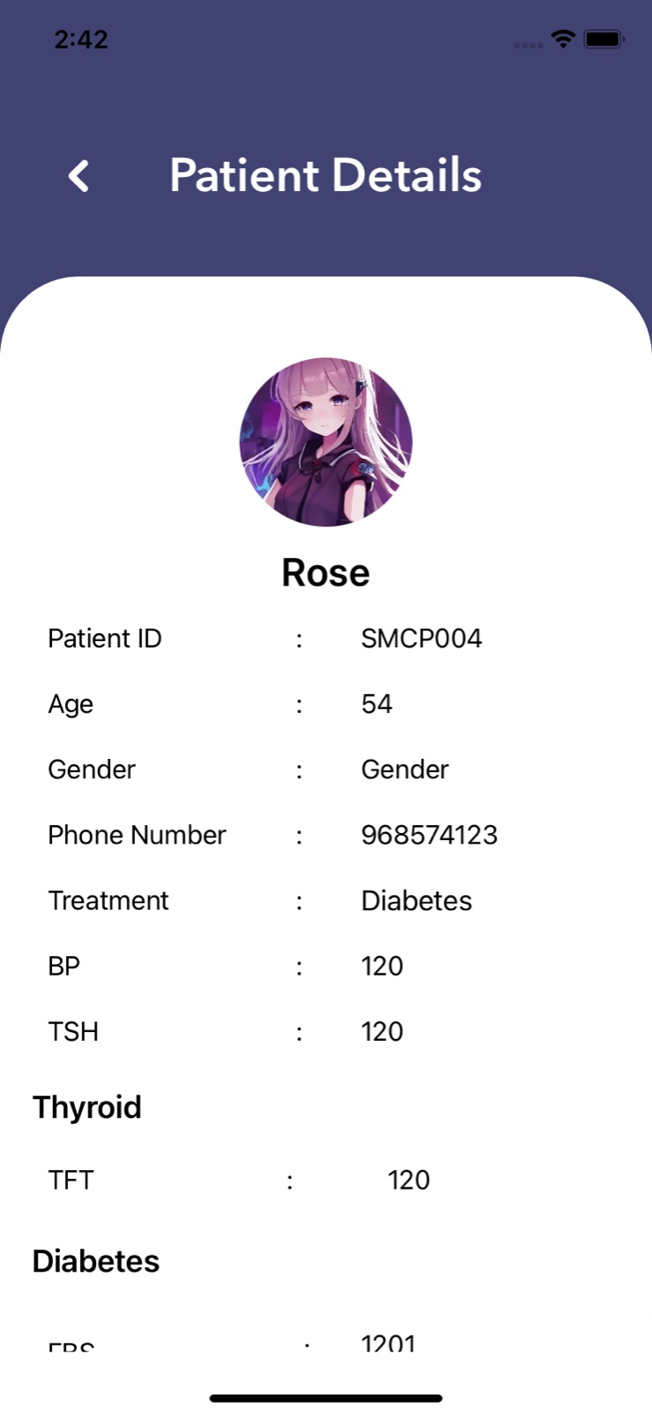
Fig. 1. The figure displays the patient details of the Medication-Reminder application from the doctor login where the patient can view all medication and Attender details.

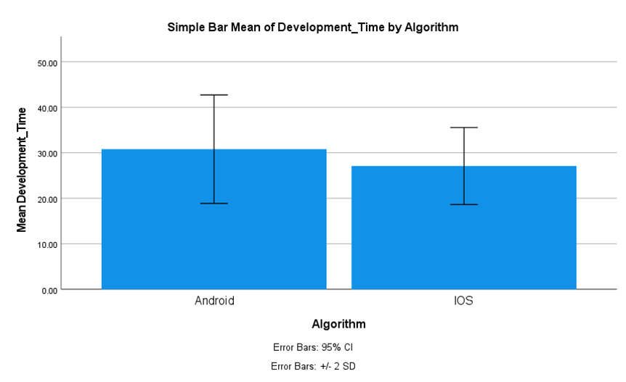
Fig. 2. Comparing the two algorithms' average development times, the iOS algorithm records an average development time of 28.75, whereas the Android algorithm records an average of 34.42. The development process for iOS and Android is shown on the X-axis, while the average development time is shown on the Y-axis. The error bar is shown as two standard deviations, or +/- 2 SD.

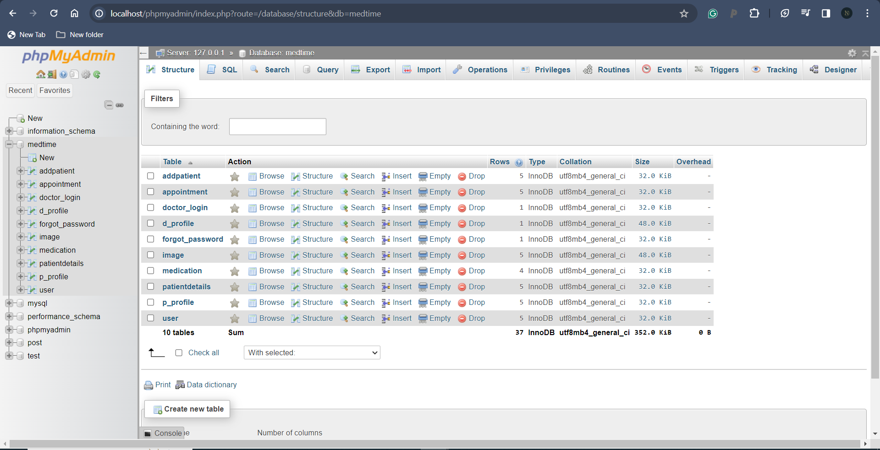
Fig. 3. The figure displays the patient task table from the database of the Medication-Reminder application. This table contains the serial no, patient ID, selected titles for patients, data, and feedback. This table helps the doctor and patient to interact with each other regarding the problems that the patient is going through and the feedback that the doctor gives to the patient to maintain good health.

